CIAO Focus Reference Sheet

Follow these steps to archive last month’s CIAO Focus and to launch a new one. You will learn how to post the changes to the test server and then copy them over to the live server using tools such as Dreamweaver, WinSCP, and Photoshop.
Start by first logging into the workstation only (UN/PW: dkv/adv3nture) on machine outside of video room and then launch Dreamweaver.

- Update Test Site (http://ciaotest.cc.columbia.edu/)
- Connect to test server.
  - Go to Site > Manage and connect to CIAO server with own UNI username (rs2499) and password. Click “OK” and then on “ciao-test” directory on right.

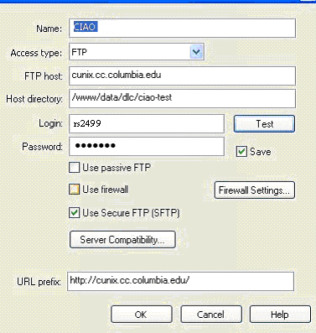

- Create archive file.
  - Find “Ciao-test” and open “Focus” folder. Duplicate the last .html file (by right clicking on it and selecting “duplicate.”)
  - Rename according to year and month of focus. Dates will be off by one month (e.g., 0902.html).
  - Open the file to update it (click on “design” icon at top if see code).
Note: The style may appear different when working in Dreamweaver. It will automatically be applied on the live site.
  - Copy the focus elements from the live site and paste over old info on archive file.
Note: Remember to use “Edit>Paste Special” to remove any formatting. You will need to paste the headlines as text only. You don’t need to do this for pasting plain text or URLs.
  - Remove hyperlinks to outside sources.
Note: Select outside source then go to “Properties” panel at bottom of screen. Cut link from “link” field and paste below name of source on main page.
  - Add image.
Note: In “Properties” panel at bottom of screen update these fields with information from the test site:
“Src”--Paste image location (right-click on image and select “copy image location.” Only the info after the domain name is needed “_media/images…”
“Link”—Paste link location (right-click and select “copy link location” and shorten per above.
  - Update date on HTML page.
Note: On bottom panel click on “Page properties.” Select “Title/Encoding” and update month.
  - Save file.
- Add archive file to foci index page.
  - Note: Go to “main” folder and click “focus.html.” Add headline and link to focus document just created. (Can copy link info from previous month and update with new date info.)
  - Save file.
- Create the new CIAO Focus
  - Edit the file ciao-test/index.html.
Note: Follow the same editing process for creating the archive file.
  - Resize image if necessary (260w x ~279h).
Note: Use Photoshop. Save image as JPG for web. Quality should equal ~50. Save to desktop. (e.g. gaza_strip_map_small.jpg and gaza_strip_map.jpg)
  - Use Winscp to upload images to “_media/images” folder in “ciao” and “ciao-test” directories.
Note: host = cc.cunix.columbia.edu
  - Go back to Dreamweaver and update image info in properties panel
Note: Src =_media/images/gaza_strip_map_small.jpg
Link =_media/images/gaza_strip_map.jpg
- Review/approve work on test site.
  - Go to http://ciaotest.cc.columbia.edu/ (UN/PW: ctest/ct3st)

II. Update Live Site (www.ciaonet.org)
- Open ciao-test directory files.
  - Note: display code and delete any hard links (i.e. http://ciao-test.columbia.edu). Select all/copy code.
- Open related file in “ciao” directory and paste new code.
    - archived focus file (ciao\focus\0902.html)
    - foci index page (ciao\main\focus.html)
    - new images (double check they’re in there--ciao\media\images)
    - home page (ciao\index.html)

