Project Approach:

Columbia International Affairs Online Web Site

Prepared by
RDW Group Interactive Factory

July 14, 2006
Table of Contents

Executive Summary: Overview 3
Outline of Solution Set Components 6
Supporting CIAO’s Strategic Objectives 9
Installation and Implementation for CIAO: Potential Project Outline 11
Public Site 11
Content Management System 12
User Management 12
Content Indexing & Publishing 12
Project Management and Primary CIAO Deliverables 14
Constructing a Navigational Prototype 21
Home Page and Template Design for CIAO 22
CIAO Site Content Management 23
Hardware and Software Recommendations and Assumptions 27
Testing for CIAO 29
CIAO Administrator Training 30
Optional CIAO Electronic eNewsletter and Email Tool 31
Optional CIAO Maintenance and Support 34
Web Site Application Development Assumptions and General Parameters 36
Task Chronology and Budget 37
Appendix A: About IFactory 39
Appendix B: IFactory’s Long-term Value Proposition 40
Appendix C: Approach to Defining CIAO’s Content Management Solution 41
Appendix D: Sample Projects 45
Reviews 47

Executive Summary: Overview
Columbia International Affairs Online (CIAO) seeks to more effectively leverage web based tools and technology in order to allow CIAO customers to gain access to greater quantities of research and teaching content. To support these objectives, the current engagement seeks to leverage the organization’s successful editorial process and large library of (primarily) PDF content in order to provide researchers with bibliography, enhanced search and integrated search functionalities in a manner supporting current contributors and online customers.

The following document provides an overview of our suggested approach towards meeting the needs of CIAO. We anticipate saving CIAO both time and money by employing the existing Columbia University Press Mark Logic platform and hardware solution. In addition to reducing costs and development risks inherent in such a complicated undertaking, such an integrated solution will provide CIAO with economies of scale across maintenance, software and hardware procurement as well as future site expansion. That said, we have much to learn about your specific objectives and we expect the final CIAO feature set will be modified as we further discuss and understand the needs of your various audiences. This document should be considered a launching point for our discussions as we collaborate in order to define a final project specification together.

Leveraging the online publishing strengths and the application development skills of RDW Group Interactive Factory (IFactory), we will define a solution supporting both online research and technical objectives serving the immediate and long-term needs of CIAO.

Our approach to the web initiative will be to separate the project into three distinct phases:

- Requirements Analysis and Concept Development: We will work with CIAO to confirm the organization’s business objectives and current project goals, confirm target audiences and articulate online publishing and administrative rights. During the initial phase, we will construct use case scenarios, storyboards, functional specification, primary interface templates and a navigational prototype through a set of iterative deliverables, thereby providing CIAO with significant opportunity to collaborate and course correct with us as we continue to gain a deeper understanding of your audiences’ needs. We will also identify and confirm integration points with Columbia’s existing web based software and hardware resources. As a result of this phase we will be positioned to develop and deploy the CIAO site and publishing application.
- Production: Drawing from the specifications and user requirements defined in the initial phase, IFactory will construct the CIAO content management system and online publishing solution. The phase will consist of a series of deliverables designated as Alphas, Betas and Golds, each providing a greater set of functionality and each subject to rigorous testing by both IFactory and the CIAO team.
- Implementation: Though described as a separate phase, the implementation component of your engagement will be fully integrated with the Production phase. Our implementation phase includes integration with your current server solution and Mark Logic platform. The employment of such existing components will be clearly defined in Phase one and will result in CIAO’s ability to share resources and standardize project components, thereby laying the foundation for future cost effective site management and expansion.

As web technology and application development partners serving the academic and online publishing communities, Interactive Factory seeks to contribute to CIAO the experience we have garnered through a variety of recent projects such as those noted below:

Ford Foundation: Defining content management solutions, server management and developing a database serving hundreds of Ford Foundation Program descriptions and documents within a multi-layered administrative environment.

Greenwood Publishing’s Praeger Security International: Offering a current and in-depth database presenting international security content including defense and foreign policy strategy, regional security, military history, and terrorism data. The online tool provides professionals with access to over 500 titles as well as expert analysis, primary documents and an annotated bibliography. The XML documents are derived from multiple sources and in multiple structures. IFactory deployed a solution in which the documents are searchable and presented in a unified format. The site includes an AJAX browse interface, allowing users to navigate to a large hierarchical subject listing consisting of over 12,000 topics. Search is initiated while typing the first few letters of a term without having to wait for the query to be posted to the server before results are retrieved. The site also includes a database of terrorist incidents which may be searched and browsed by location or by date thereby providing a result set that may be graphed as an illustrated view of incidents.

World Bank’s Disease Control Priorities Project: Funded by the Bill and Melinda Gates Foundation, IFactory recommend and implemented an open source solution integrating content from an array of sources such as:
- Disease Control Priorities in Developing Countries, 2nd edition, (DCP2). As a print publication, DCP2 has 73 chapters covering 1,300 pages in length.
- Priorities in Health, a “companion volume” to DCP2 summarizing the key policy messages. Priorities in Health consisting of some 55,000 words. As a print publication, Priorities in Health is published in seven languages (Arabic, Chinese, English, French, Portuguese, Russian, and Spanish). PDF’s of all versions will eventually be available on the DCPP website.
- The Burden of Disease database. This database estimates deaths by cause, disease burden and risk factor burden, presented for countries grouped by the World Bank’s 2003 classification as low- and middle-income countries. The print edition of the book consists of some 550 pages, approximately half of which are tables.
Oxford University Press: Architecting, deploying and maintaining the Dictionary of National Biography (www.oxforddnb.com), the American National Biography (www.anb.org), and the African American Resource Center (www.oxfordaasc.com) online reference applications. These applications provide extensive searchable and browsable repositories of reference articles. In addition we have built and maintain the account management system that is used to handle and maintain all online subscriptions outside the UK for all of OUP’s online reference works. This system integrates with OUP’s SAP financial system as well as OUP’s UK subscription system. At the risk of sharing feedback, the DNB application received the following reviews:
- “An astonishing piece of work: a colossal, beautiful, fully functional and utterly user-friendly engine of enlightenment.” Noel Malcolm, Sunday Telegraph, October 24, 2004

- “. . . undoubtedly the history-publishing event of 2004 . . . a remarkable and sophisticated updating of a Victorian masterwork . . . an intellectual wonderland for all scholars and enthusiasts.” Tristram Hunt, The Times, December 11, 2004
RR Donnelley Printing: Designing and developing a custom publishing system drawing data from six unique data sources and allowing users to build online text book by selecting individual chapter content and arranging as needed. In addition, users can customize the cover and title page and upload their own content. The books are generated by combining individual PDF files and printed, bound and set directly to the user.

During our potential engagement with CIAO, we will seek to confirm work flow patterns, define use case scenarios and cluster data and transactions around logical end user pathways. Specifically, we will organize and define an online application around the following primary components:

- Existing Data: confirming format, relations, naming conventions and integration options and requirements of the existing data sources
- Target Audience Needs: anticipating user (use case) scenarios and transaction paths
- Search Criteria: architecting search conventions around primary content clusters, categories of data, keywords, text search options and anticipated user needs
- Existing Infrastructure: confirming search and application format and configuration for both mark Logic and hardware solutions, enabling CIAO to fully leverage existing solutions and processes
- Content Management Work Flow: identifying and enhancing the process for gathering, reviewing, vetting and publishing online materials providing for one level of administrative rights for editing content, organizing content and publishing content

We are confident in our ability to contribute to the success of the CIAO solution in a cost effective manner and hope to have the opportunity to serve CIAO.

Outline of Solution Set Components
We have based our pricing approach on the expectation that IFactory will design, develop and deploy a new application serving multiple audiences and integrate this application into Columbia’s existing infrastructure. It should be noted that this will allow us to recognize a significant savings in our development process because we will be able to use or extend much of the existing infrastructure that we have put in place for the current projects that we are working on for Columbia University Press (CUP). The following these areas:
- Subscription Management System – We are deploying a subscription system for CUP and expect it will require little to integrate the new CIAO with this system.
- Access Control – the access control module that we deploy for CIAO will be an extension of the system we are building for the Granger, Gazetteer and Encyclopedia sites. Again, we anticipate we will need to do very little to make it work in he CIAO environment.
- XML Database – We will use the same Mark Logic XML content repository. This platform will make it much easier for us to develop cross-site search functionality and will save in hardware costs as well.
- Site functionality – Common site functionality such as email support, citation support, OpenURL, etc will be shared across all of the sites.
- Reporting – The reporting system that we are currently building will be easily extended to support the CIAO reporting needs.

The following section outlines the deliverables associated with our proposed solution and this document’s cost structure spanning the architectural, development and implementation

Application Architecture:
- Project profile confirming goals, assumptions and target audience
- Content inventory identifying various content types, sources and categories
- Work flow maps defining the means by which we imagine administrators working within the application will manage the following processes:
- Add, edit, delete a journal article
- Post new or change web site content (such as news or an event)
- Add an authorized user
- Use case scenarios codifying the primary transactional elements, process steps, individual components and data needs for approximately six primary use cases such as:
- Search
- Access an individual product
- subscribe
- Browser titles
- Browse topics
- Sign-up for an event
- Storyboards of up to 12 external screens and six administrative screens
- Page specs noting functionality for up to six highly functional pages
- Concept brief defining project deliverables and approach to implementation

Application Specification:
- Navigational prototype integrating an approximate total of 12 external screens and six administrative screens into a navigable white screen solution
- Review of navigational prototype with CIAO project champions and collection of feedback, corrections and comments via conference call
- Functional specification articulating all online functional and transactional elements
- Technical specification defining data schema, integration points and development requirements

Home Page and Page Template Development:
- Creation of a new site design based on one art direction session
- Design of new home page based on three initial mockups and two iterations on CIAO’s mockup of choice
- Master template for use throughout the application
- Approximately 12 unique template for unique content sections such as those examples noted below:
- Product/document list (using one format for various product types such as journals, books or working papers)
- Individual product/document display
- Master calendar view
- Calendar event detail view
- Quick search
- Search results
- Index
- Browse
- Subscribe
- Course pack template
- Map template
- News and press
Content Management:
- Develop and deploy a single administrative system comprised of three master administrative levels
- Develop the system in tandem with the current Columbia University Press CMS (currently under development by IFactory) in order to provide for a single interface access solution and to potentially provide for shared content
- Provide content management elements capable of providing for updates to up to six primary content categories such as the examples noted below:
- Product/document overview/list
- Product/document detail
- Author detail
- Course packs
- Calendar events
- Standard content (for marketing oriented section)

Search Integration:
- Define search solution consisting of:
- Installation of the search engine
- Organization of content types around primary search criteria such as:
- Title
- Author
- Subject
- Keywords
- Publication date

System Configuration:
- Integrate the content provided from CIAO
- Integrate existing Mark Logic platform

Server Configuration:
- Configure the initial site within the current Columbia server set, allowing Columbia University Press to share sites within one server set

Search Engine Optimization:
- Integrate content and metadata

System Testing:
- Apply test scripts across use cases and test along primary test criteria consisting of:
- Unit testing
- Integration testing
- Functional testing
- Load testing
- Platform testing

Deployment:
- Produce and deploy the final web site

Project Management:
- Ongoing organization of the functional, technical, budgetary and schedule requirements
- Weekly conference calls with the CIAO team
- Monthly team status and milestone reviews
- Implementation management
- Quality management
- Training implementation

Training:
- Provide one session of onsite training and support for the CIAO site administrator(s)

Optional Maintenance:
- Provide annual maintenance providing for:
- Application maintenance
- HTML and content updates
- Code and scripting modifications
- Database support

Supporting CIAO’s Strategic Objectives
Prior to defining the CIAO web solution we will work to confirm specific objectives in order to define a clear web strategy. We will focus on confirming CIAO’s primary objectives and target audience requirements. To start this process, we have identified the below noted potential goals and processes for your review.

Columbia University Project Goals:
- Enhance CIAO’s infrastructure in order to better leverage technology allowing CIAO users to engage in more useful research and teaching activities
- Create a robust technical solution providing the CIAO staff and editor additional time allocated to gaining additional contributors and articles
- Migrate CIAO current and historical PDF documents to a searchable XML format
- Introduce bibliography cross reference capability via a format such as CrossREF
- Provide for online bibliographies supporting OpenURL
- Enable CIAO librarian clients to integrate CIAO content into broader cross-source search options

Columbia University Content Summary:
- General Content Information is noted below:
- Current site received 200,000 hits per week during the academic year
- Approximately 2500 new pages are loaded each month
- One third of new pages are journals
- The standard individual content product is approximately 25 to 40 pages in length
- (If the content is XML we will have the ability to chunk the content at the section or sub-section level allowing for finer grained information retrieval.)
- Content is primarily provided in PDF format
- Content is text heavy with minimal visuals or data sets
- Visuals or data sets are primarily embedded in PDFs
- Editorial Process:
- Current process employs a manual method of relating themes and content and removing unnecessary content (from CIAO’s screen scraping collection efforts)
- During the initial planning portions of the engagement, IFactory will review the editorial process in an effort to determine if we may offer process improvements such as improvements in the way content is collected. We will look for areas where the process may be automated. Though, we do not expect there is a single silver bullet solution, anticipate being able to assist in finding a number of different incremental improvements to the process.
- Subscription Authentication: We will integrate CIAO into the subscription system we are providing CUP for the Gazetteer, Granger and Columbia Encyclopedia sites. The system provides support for the following components:
- Institutional and individual users
- Support for networks and consortia
- Support for trial and gratis subscriptions.
- A full range of authentication mechanisms including: IP, username/password, referring URL, library card and if necessary ATHENS.
- OpenURL support including the ability to register a library’s OpenURL resolver.
- An automated notification system for communicating with clients based on subscription events with full mail merge capabilities
- Support for signup forms
- Integration with back-end billing systems

- Working Papers:
- The CIAO site’s primary value to users focuses on working papers content
- Working papers are received in a variety of formats, many from smaller sized, time constrained, research teams
- CIAO’s current site includes an upload form for working paper submission, however the form is not widely employed
- The working paper editorial process is, by necessity, manually intensive
- Working papers in particular are subject to collection (screen scraping) from supplier sites, which is a lengthy, manual process which limits the collection and organization of data
- IFactory believes the opportunity to try and enhance the working paper collection process offers significant potential for both time saving and content standardization, however we are cautious in modifying such a delicate process; as such during the initial portion of the engagement IFactory will evaluate potential changes such as ….
- Investigating the feasibility of using RSS or web services to help automate the delivery of content to CIAO
- Constructing screen scraping tools to improve the current process
- Journals:
- Journals are provided from a variety of third party publishers, many with well founded concerns regarding the distribution of their unique intellectual property
- Publishers provide a sample of content and CIAO (often) compromises on the depth of content provided on the CIAO site, as most publishers will not provide full online content (abstracts and TOC are provided)
- Journals are all collected via automated screen scraping and therefore require editorial activity to accommodate various types of content
- IFactory will review the journal content collection process in order to determine the appropriateness of process improvements such as the below noted examples:
- Providing a web service for the automated delivery of articles
- Working with the supplies of the content on RSS functionality that could provide the potential content to CIAO in XML and in an automated fashion
- Screen scraping tools to help improve the scraping process.
- Books
- Books are not a primary content draw and were originally provided as an adjunct content
- Case studies:
- CIAO commissions about one case study per month and works directly with the author (which is not the case with working papers or journals)
- Case study content includes minimal or no tables, related docs and data sets

Installation and Implementation for CIAO: Potential Project Outline
Interactive Factory has developed numerous online platforms for different academic clients. We have taken the knowledge gained from such experience and combined it with the information received from your RFP to propose a rough set of functionality for the CIAO project. We have used this proposed feature set to develop a set of development estimates which we have included in this response. The following provides a brief description of each of the components of the CIAO site.

Module Breakout
We have separated the project into the following modules which are all described below:

- Subscription Management System and access control module for the web site
- Main CIAO site including the Home page, marketing pages, search, browse and all content related pages for all of the CIAO content
- Publication Management System
- Reporting
- Optional features

Subscription Management System
The IFactory coded Subscription Management System (SMS) handles the ability to create user accounts for the application. This system allows the management of personal, institutional and consortia users and can handle the following types of authentication:
- IP
- Username & password
- Referring URL
- Library Card
- Athens

The SMS supports personalization in the form of a name and image that can be displayed on pages of the site. OpenURL is supported and a users OpenURL resolver can be added as part of their account information.

The SMS includes functionality for managing subscriptions including CRM features for handling renewal notifications and creating different sorts of subscription offers. We feel that expanded authentication possibilities and subscription capabilities of the system will allow CIAO to grow into the system if and when you are ready to consider more elaborate subscription access to the content.

Access Control
This module works in conjunction with the SMS to limit access to the site. In addition to supporting the various types of site access it also provides abuse detection support to defend against users downloading all the content to which they have access.

Public Site
The public facing pages of the site will require special care and handling to insure good user interface, navigation and design decisions are made. These pages include the CIAO homepage, and primary interface template. IFactory has been designing websites and interactive media for over 10 years and will work with you to construct a site that is attractive to your specific audience needs.

CIAO Site
The content will be stored within the Mark Logic XML content repository. Search will allow users to search all content to which the user has access. We assume we will support the following features within the CIAO solution:
- Browse – Provide a number of different ways to browse content. In addition each online book or chapter will have a keyword list or subject list (a.k.a. a topic map) that will provide an alternate way for navigating entries. The keyword list or subject list will be made up of entries from the reader’s guide or from the index. Depending on the complexity of the keyword list or subject list we may suggest using a type ahead interface to navigate.
- Quick Search – We are assuming that quick search will be available from all pages and will search a variety of existing topics such as author and topic.
- Advanced search – We are assuming that there will be an advanced search interface available to users that will allow users to provide a more exact search. Search will support wildcards and Boolean operators and in addition to the fields that quick search will search. Advanced search will search the full text and image captions. The ability to filter by source will also be provided.
- Search Results – Results will be paginated. The total number of results will be shown and the user will be able to navigate between the pages. Results can be sorted by entry headword and by source. The ability to filter by source will also be provided. Searches that produce a single result will go straight to the selected entry. Results can be selected.
- Help – A context sensitive set of help content will be created that can be accessed from anywhere in the site. Users will be taken directly to the section of the help that is appropriate for the page from which they came.
- Document/Product Display – This is the main document content display page. Documents will include the following features:
  - Entries may have 0 or more images
  - The print page number will be displayed
  - A print friendly version of the document can be displayed
  - The document can be emailed and entries can be emailed as text or HTML
  - A link to a citation popup will be provided. One or more citation formats can be provided
  - Documents can be selected and selections will be remembered throughout a user’s session

Content Management System
A Content Management System is included as part of the solution enabling CIAO to add and update content throughout the site. There will be an interface to allow the content on the static pages of the site to be updated.

User Management
To some extent, the system will be integrated with the current CMS development efforts at Columbia and provides a simple user management system that allows for three classes of users:
- Master Administrators
- Editors
- Publishers

Content Indexing & Publishing
The CMS gives administrative users control over content indexing and publication. The administrator can control what documents get indexed and/or published to the live site. All content and indexes can be previewed on the staging site before they are published to the live site.

Reporting
A reporting module will provide two different kinds of reports:
- User reports will provide COUNTER compliant reports. CIAO will be able to view both user reports and aggregated reports across the entire system.
- We will also provide standard web reporting for CIAO personnel.

Other Potential Features
The following is a list of potential features that we have not included in the core feature set but that could be included in the system if desired:

- Document Display Enhancements
  - If the entries include bibliographic sections and the necessary tagging is in place OpenURL links will be displayed if the institution has a registered OpenURL resolver or CrossRef could be used in the case where there is not a registered resolver.
  - If the user comes to the entry from the search results of a full text search the search terms could be highlighted in the text.
  - Emailing the document could be enhanced to provide an email to a link to the article. The link would be publicly accessible for a limited period of time (1-5 days).
- Search History & Selection List Enhancements
  - Save information across session. Users will be required to register with a username & password. Once they have registered their search history and selection list can be saved and be retrieved whenever they return to the site.
- Search Results
  - The search results could display the search hit on full text searches. We would provide a snippet of the text from the document where the first occurrence of a search term appears and enough context to understand how the term is being used (around 20 words before and after the term).

Project Management and Primary CIAO Deliverables
Interactive Factory practices a highly iterative and collaborative development process for all of our projects. We assume much of the Architectural and Design Phase will be an interactive experience involving both teams. Below we provide you with an overview of the primary stages of our process so you may better understand our goal of defining and building your solution one step at a time.

Project Management
Critical to our process are our producers and their expertise in academic publishing project management. The producer will oversee the entire process and will serve as CIAO’s primary point of contact throughout the duration of the project.
The producer will maintain CIAO’s client area with real time documentation including project status, scope definition, schedule, communication log, and deliverables.
Project Profile:
Definition: Summary of CIAO’s business goals, competitive context, target audience, selling process and desired application functionality. We seek to define the web strategy as a function of CIAO’s business strategy.

Purpose: To confirm client long term goals, product or positioning goals, tactical (immediate) project goals, target audience objectives (what the audience seeks with the application), transactions (descriptive) and metrics of success. This document will set the direction for the functional specification and concept brief.

Feedback considerations: CIAO must author or collaborate with us on this document. Your feedback must provide for correct goals and tactics thereby enabling us to set complementary project goals and so we may make ongoing decisions based serving the client business needs.

Approval implications: The document will act as the thematic guide to project decisions. For example, if the project profile has identified a goal of supporting an existing audience channel then we will evaluate functional and design decisions in light of how they help or hinder that goal. The project profile seeks to ensure we are progressing in the correct direction and towards the appropriate goals prior to organizing content, use case scenarios, functional specs and web service design. When in doubt or at a cross roads, we will refer to the project profile for directional guidance.

Storyboards:
Definition: Screens that will depict application functionality are produced in HTML. The storyboards include the placement of screen elements, navigation between screens and various points of access of the screens. They also show any data that is captured form the user. Storyboards do not show design elements.

Purpose: The storyboards confirm that all screens, screen elements, data types, data constraints, and validation rules have been identified.

Feedback considerations: Are all the necessary elements represented on the page (i.e. navigation, footer, etc)? Is the screen real estate allocated correctly? Are the elements represented in the way you expect them to function and accordance with the functional specification (i.e. does “search” link to a separate search page or does it allow you enter a keyword hit return executing the search query)?

Approval implications: No new screen elements, data fields or validation rules will be added from this point forward.

Functional Specification:
Definition: The functional specification describes the intended capabilities of an application. This document details the purpose of the system, what it is supposed to do, and exactly what the functions of the system are and how the system behaves. The specification considers the front-end user experience and the back-end implementation.

Purpose: This document means to create consensus as to how the CIAO application will operate. It is an opportunity to work out the functional behavior at a conceptual level. It does not specify the technical details of the coming development.

Feedback considerations: Ask about any vocabulary you are unsure about or apparent language inconsistencies that appear. If anything is incorrect, unclear or ambiguous, now is the time to clarify. If you have change requests in terms of how something will function, be sure to understand the implications of the change.

Approval implications: This document will be used as a guideline for the actual implementation of the online reference application. No changes to functionality will be added after the final approval of this document without a change in the project scope, which may impact schedule and budget.

Workflow Map:
Definition: A workflow map is a graphical representation of a work process. It shows the sequential steps in a process and identifies the individuals (or systems) responsible for each step. A step may have a main action plus multiple side actions that must be completed before progressing to the next step.

Purpose: The main purpose of this document is to clearly define who (or what) must do what, when and how.

Feedback considerations: Are all steps and actions present. Is the flow sequence correct? Have potential departures or anomalies been identified?

Approval implications: This document along with the Functional Specification will become the basis for the system architecture. Technical development will adhere to the workflow map and the functional specification.

Use Case Scenarios:
Definition: A generic scenario that describes an interaction between a user and the CIAO system in a detailed manner including the main flow and any alternate or sub-flows. The scenario includes a description of how an interaction is accomplished or fails. It also includes any prerequisites that must be in place before a user can take the action. Example:

Input: User is at the View Users page
Output: User has created a user
Prerequisites: User is logged in as an Administrator
Process:
- User selects the “add” button.
- System displays the Add User page.
- User enters new user information: email, password, re-enters password, and selects one or more user roles (Administrator, Editor, Contributor, and Scheduler).
- User selects the “Add User” button.
- System creates the new user.
- System displays the View Users page and notifies User.

Purpose: Use cases are user-centric and consider the information the reference librarian (or other appropriate user) will need in order to perform an action. It assists in thinking about the system development from the front-end user experience vs. the back-end.

Feedback considerations: Are all potential Use Cases included that will be performed on the system? Have all the alternate or sub-flows been included? Has the user experience been considered: information display, error messages, or optional actions?

Approval implications: Use cases define the exact behavior of the site and are included in the Functional Specification.

Page Specs:
Definition: Page specs may be produced to describe complex user interfaces. They provide more details of the dynamic nature of the application than storyboards can do. They concentrate on the complexity of the visual design while use cases concentrate on the interaction between the user and the application. Page specs are based on the storyboards but are annotated to describe interactions between page elements, values which are allowable in particular fields, and any dynamic behavior on the part of the system.

Purpose: Models complex, dynamic behavior on a single page. Used to confirm data types, data constraints, and validation rules.

Feedback considerations: Are all the necessary functional elements represented on the page? Are the elements represented in the way you expect them to function and accordance with the functional specification (i.e. does “search” link to a separate search page or does it allow you enter a keyword hit return executing the search query)? Are all fields requiring user input described in terms of allowable data and error conditions? Are all interactions between fields called out?

Approval implications: No new screen elements, data fields or validation rules will be added from this point forward.

Technical Specification:
Definition: The technical specification defines precisely how the functionality of the application will be built. It includes the system architecture, relevant data schemas (including CIAO data sources and or data structures such as XML), performance considerations and technology choices.

Purpose: This is a formal document describing all of the technology which will be employed to develop the CIAO web site. Although it is not meant for a general audience, it should be clear why each piece of technology is required for the project and what purpose it will serve in development.

Feedback considerations: For each major component described in the functional specification there should be a technology identified to support it. If the functional specification describes a user search, the technical spec should describe the search technology to be used, from the front-end interface to the data-loading components on the back end.

Approval implications: This document will be used as a guideline for the actual implementation of the application. No changes to technology will be added after the final approval of this document without a change in the project scope, which may impact schedule and budget.

Content Inventory:
Definition: A summary of all pages/content presentations within the current application.

Purpose: To identify which pages/content presentations on the current application will be employed, which content can be deleted or will be edited for the new application.

Feedback considerations: Confirmation of the inventory. Inventory can then be used to assign content writing or editing to owners.

Approval implications: This document will be used when creating the content delivery schedule.

Navigational Prototype and Prototype Focus Group Report:
Definition: A report based on focus group feedback of a review of linked navigable storyboards.

Purpose: The results of focus group discussions provide information about user needs, feedback on current site design, feedback on site redesign ideas, etc.

Feedback considerations: Validity of results dependent upon accuracy of testers as representatives of target audiences.

Approval implications: Decisions about navigation, features, and design will be measured against Focus Group Report results.

Concept Brief:
Definition: A summary document of all deliverables created during the Concept phase of the project. The brief encapsulates the goals, objectives and functional approach of the project.

Purpose: A final opportunity to confirm the project goals and direction. A blueprint for project design and production.

Feedback considerations: Have all of your feedback points during the Concept phase been incorporated? Does anything seem unclear or unresolved? Is the project on course and ready to begin the next phase?

Approval implications: This signals the successful completion of the Concept phase and indicates all is in order for beginning the design and development processes. At this point in the project, the schedule is reconfirmed by both teams to make sure it matches the course set forth in the Concept Brief.

Primary Template Mockups v.1:

Definition: First round of template mockups. Including home page and master template designs showing a total of three alternatives all based on an art direction document.

Purpose: To present design options from which a single design is chosen. The chosen design becomes the basis for future design changes and all CIAO application screen designs.

Feedback considerations: Which design most closely meets the defined goals of the reference application? Are there elements of more than one design that you would like to see combined? Is the page real estate used so that the most important content is visible and/or easily accessed? Is the overall aesthetic pleasing?

Approval implications: At this point you are selecting a design option from which future modifications will be made. Your feedback should be as comprehensive as possible ensuring that the next round of mockups is closer to your goals.

Primary Template Mockup v.2:
Definition: Second round of home page and master template design incorporating feedback from round 1. This should be quite close to the final design. Often at this point the design that is being revised here will also be expanded to show a second level page.

Purpose: Further refinement of the application interface design.

Feedback considerations: Is all of your feedback addressed in this revision? What changes still need to be made to meet the application goals? Your feedback should be comprehensive as this next round should be the final round of template designs. Any questions or concerns regarding the template page should be expressed as well.

Approval implications: You have accepted a design with some final changes to be made. Your feedback will be incorporated into the final mockup.

Primary Template Mockup v.3:
Definition: Third round of design incorporating final feedback from round 2. This is the final design from which the master templates and derivative templates will be built.

Purpose: Final reference application design.

Feedback considerations: There should be no feedback at this point.

Approval implications: Design approval means production can now begin on templates/pages. No changes should be made to design once production begins. If changes are introduced after approval the project schedule and scope may be impacted.

Key Screen Layouts:
Definition: To apply the approved look and feel to screens that may require specific graphic treatment. For example, complex search options.

Purpose: Further application of approved design direction to set standards for key elements. For instance if key screen includes a visual of a map, this visual treatment would be used for all graphs throughout the site.

Feedback considerations: Will graphic treatment of key screen/element work as a standard for similar elements throughout the application. Note: feedback should be minimal as design has already been approved.

Approval implications: You have accepted the layout and treatment of these key screens and any elements that may be re-used throughout the site.

Releases (Alpha, Beta & Gold):
The development process includes three product releases: Alpha, Beta and Gold. In general, the releases are cumulative - that is, each release includes all functions included in all prior releases. The Alpha and Beta releases may contain some defects or bugs. The scope of a bug is a measure of the number of features it affects. The frequency describes the number of users and circumstances in which the bug can occur. For example a failure in a login system may prevent the entire system from being used - this would be a very large issue, whereas a failure that completely prevents a particular feature from being used is major, but is limited only to that feature.

Alpha:
Definition: Alpha release represents the first "functionally complete" CIAO delivery. Artwork may not be final, but you will be able to see how everything is going to fit together. On occasion, there are multiple Alpha releases, depending on the nature and complexity of the project. These are used when testing of particular product features is necessary. An Alpha release is delivered with a known list of bugs. Any known major defects do not prevent use of more than 20% of the functions. This release has not been performance tested or optimized.

Purpose: This is a point for all parties to review and test the functionality of the product.

Feedback considerations: Does the functionality match the functional and technical specification documents? Is the user flow as planned? Are error messages present and meaningful?

Approval implications: Rather than giving approval, this is a time for feedback and bug reporting. Review should be thoughtful and thorough. If you believe enhancements are necessary, they are best considered at this time (some may be easy to incorporate while others may require a change in scope). All bugs should be reported via the IFactory bug database. Bugs that are confirmed by your producer will be fixed for the Beta release. At this point the schedule will often be re-assessed and possibly adjusted based on the depth of the feedback

Beta:
Definition: Beta release means the product is "feature complete". The CIAO site is reviewed by all parties to ensure it meets all defined requirements and user expectations. As with Alpha, there may be several Beta releases as bugs, errors, and minor changes are made; successive Betas will be released to correct them. A Beta release has no known major bugs or showstoppers. The release may contain minor defects, which are documented at time of delivery. Any minor defects do not prevent use of more than 15% of the functions.

Purpose: This is a point to fully test the product. All bugs reported in Alpha should be verified as fixed. Newly discovered bugs should be reported.

Feedback considerations: Were the bugs and/or enhancements reported after the Alpha release fixed for Beta? Are any new features behaving as planned in the functional and technical specification documents?

Approval implications: This is the final review before the Gold release. All feedback and bug reporting should be included. No changes can be incorporated at this point without impacting the project scope.

Gold:
Definition: Gold release means the CIAO product is "feature complete and in its final revision." As all outstanding bugs and changes are made during the Beta cycle, the final Beta becomes the final release. A Gold release has no known showstoppers, major or minor defects. Any cosmetic defects do not affect more than 5% of the screens.

Purpose: This is the final release of the product.

Feedback considerations: There should be no feedback at this point.

Approval implications: Approval means the product has been accepted and can be released. Development is now complete.

Project Analysis/Post-Implementation Phase:

After delivery of the Gold Release, we will meet with CIAO to discuss the project. Topics for discussion include:
- Satisfaction with CIAO project deliverables
- Satisfaction with project process
- Future development initiatives

In the post-project analysis we will gather your feedback in order to improve our engineering, design, and project management methodology. Your feedback will enable us to better serve you.

Project Management Tools for CIAO:

Client area description
The best possible approach to working on the development of a web site, is one in which there is a great deal of communication. Our role is to provide relevant guidance and suggestions to approach strategy, design and technical specifications. However, we rely heavily on input from our clients as to their preferences, unique constraints, and internal processes.

As a result of working on projects for large organizations where many people need to review and contribute to the process, we have instituted areas of our web site for ongoing development which are password protected. These areas facilitate and document the site's development as well as enable the process to be seen by anyone you share the username and password with. We will establish a site development area which will show notes from the kickoff meeting, concept brief, design document, initial thumbnail sketches, changes to color, navigation, and so on with the appropriate documentation. All of this material will remain live as the site proceeds through the development process in the event we need to refer to past work. Once the site goes live, we will keep a record of this development area for a limited time.

Bug tracking database
Another critical focus of project management, especially for projects with a significant engineering component such as the CIAO initiative, is problem tracking. We share our custom-built bug database with our clients in order to streamline this process. This bug database allows the client and the Interactive Factory team to view all outstanding bugs for a given project, listing them by priority, by status, by the team member to whom they are assigned and so on. We – and our clients – have found this tool to be an invaluable aid in tracking and fixing problems, and because it is available through a web page, it can be accessed from anywhere with only a standard web browser.

Constructing a Navigational Prototype
To further increase CIAO’s ability to serve the reference and academic community, we will construct a navigational prototype following the articulation of use case scenarios and page storyboards.

We suggest you allow a set of users to review such a navigational prototype prior to proceeding with design of your web site. Such a prototype integrates final front end and administrative storyboards into a navigable white screen presentation of the web service, allowing end users and administrators to identity points of confusion and conflict as well as suggestions for enhancements in the CIAO application design stage. Such a deliverable and review takes place before we allocate expensive design and coding resources to the construction of the CIAO web site.

In essence, the navigational prototype allows you to measure twice and cut once. The feedback provided by users is then integrated into actual template construction and design, thereby increasing the probability of CIAO meeting user needs and mitigating risk of designing a reference tool that does not meet the requirements of your user demanded academic audience. The navigational prototype, in combination with the storyboards, dramatically reduces the quantity of design adjustments and functional modifications during development.

In order to position CIAO to make well-informed decisions, specific steps include:

Navigational Prototype:
- Integration of storyboards into a white screen prototype, presenting content relationships and primary navigational pathways
- One review session consisting of an internal audience consisting of up to four CIAO team members potentially including marketing and IT as well as members of your design team
- Confirmation or modification of content organization requirements prior to the initiation of the design stage

In summary, the review of a navigational prototype (before expensive design, production and integration) will position CIAO to make well informed, user-centric, decisions regarding your new web site.

Home Page and Template Design for CIAO
Designing the Site Look and Feel
Following the definition of user content requirements and confirmation of the content administration backend constraints, IFactory will work with CIAO to design the home page and a series of standard unique page layouts. Our approach towards the design portion of the engagement will focus on saving design time and money by designing a single standard site template for use across the site and standard sub-section templates for use with content-rich sub-sections.

During the design portion of our engagement, IFactory will provide the CIAO marketing and technical teams with the following visual deliverables:

- Art Direction, defining the look and feel theme and direction
- Three home page mockups, each with a master sub-section template, providing three alternate designs for the master home page, and two rounds of design iterations on the primary candidate mockup selected by CIAO
- Up to 12 sub-section page layout designs for use within the site, each with one mock-up and one round of iteration, for pages requiring unique layouts such as the examples noted below:
- Product/document list (using one format for various product types such as journals, books or working papers)
- Individual product/document display
- Master calendar view
- Calendar event detail view
- Quick search
- Search results
- Index
- Browse
- Subscribe
- Course pack template
- Map template
- News and press

Please note, the above list is provided as our initial estimate. Working with you in the initial planning stage, we may determine more or less layouts are required. As a result of this design initiative, CIAO will have defined the site architecture, integration points with the CMS and have in hand the primary design elements for site production.

CIAO Site Content Management
The initial portion of our engagement will focus on confirming goals, organizing content, defining functional requirements and designing the site look and feel. Following this portion of the project, we will be positioned to confirm implementation and technical requirements including the suggested content management system on behalf of CIAO. We will leverage administrative capabilities and code originating in the current Columbia CMS in order to contribute to a consistent platform across your sites.

Appendix C provides the reader with an overview of how we – and you may wish to – approach the challenge of defining content management needs and appropriate solutions.

To facilitate long term administrative requirements across CIAO departments the current CMS will provide for shared entry point(s) and potentially a series of overlapping content administrative screens with the current CMS. Our goal is to enable CIAO to reduce development and long term maintenance costs. We will review the existing administrative workflow and identify pages CIAO plans on consistently updating with new or revised content. Though we have much to learn as we begin to digest your goals, we currently anticipate the content management system will provide an administrative emphasis on frequently updating pages as noted in the six examples provided below:

- Product/document overview/list
- Product/document detail
- Author detail
- Course packs
- Calendar events
- Standard content (for marketing oriented sections)

The Content Management System (CMS) will provide CIAO with the following functionality, resulting in reduced administrative costs and increased ability to serve your constituents:

- Browser-based interface – allowing CIAO admin user(s) to update content on-the-fly without knowledge of complex programming languages - adding, editing and deleting content in an easy to follow manner
- Password-protected administration - offering one level of management oversight and controls as needed
- Content archiving – providing for fast, easy archiving and retrieval by CIAO administrators
- Image uploading – enabling administrators to select images stored in their site repositories and upload them immediately with a mouse click to various (or multiple) pages in the site; note images will be uploaded through the CMS

The following pages provide CIAO with example screen shots for various functional components within the CMS. The CIAO CMS will be customized to serve your unique needs and the following screens are provided as examples.

The CMS will serve a clearly specified set of content sections. Though we will confirm the content provided by the CMS, we have initially priced a CMS serving six unique content sections, each with a standard layout.

Administrative Components
The following screen shots evince the functionality and administrative interface for the below noted components.
- Section Options: Offers the ability to change a section name, image, and hide the section
- Image Selection: Allows you to select from a library of images for various pages
- Add Page: Offers you the ability to add a new page to the section

Example Section Options

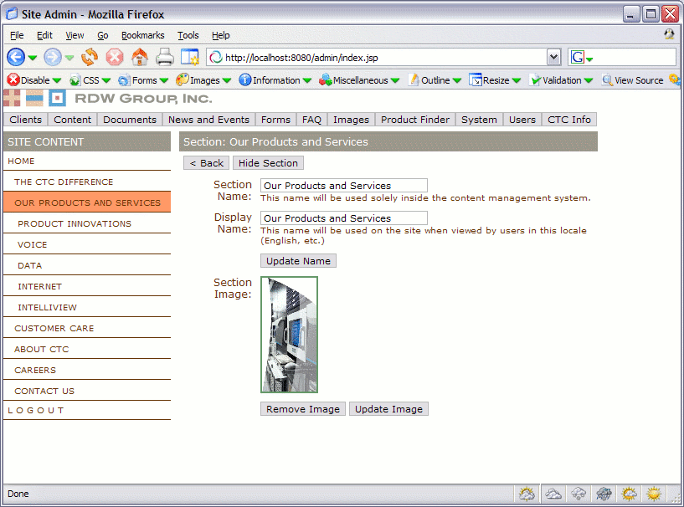

Such a screen may provide the ability to change the name of the section as it is presented in the system – the display name – which is displayed in the site’s navigation. In this example, the user may select a different image to be displayed on the right hand side of the screen when the pages in the section are shown to visitors of the site.

In this instance, if you click on an ‘Update Image’, the user is taken to the image selector screen, which is common to many parts of the application. The image selector is highlighted in the next section.

Example Image Selector
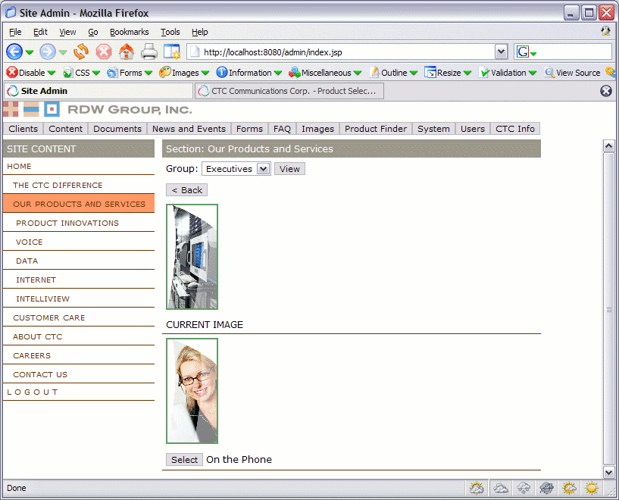

Such a screen allows you to change the image currently associated with the section. In summary, you can either select the image you wish to use, or change the image group from the drop down at the top of the page, to see if a different image group may have an image you will want to use.

Example Add Page
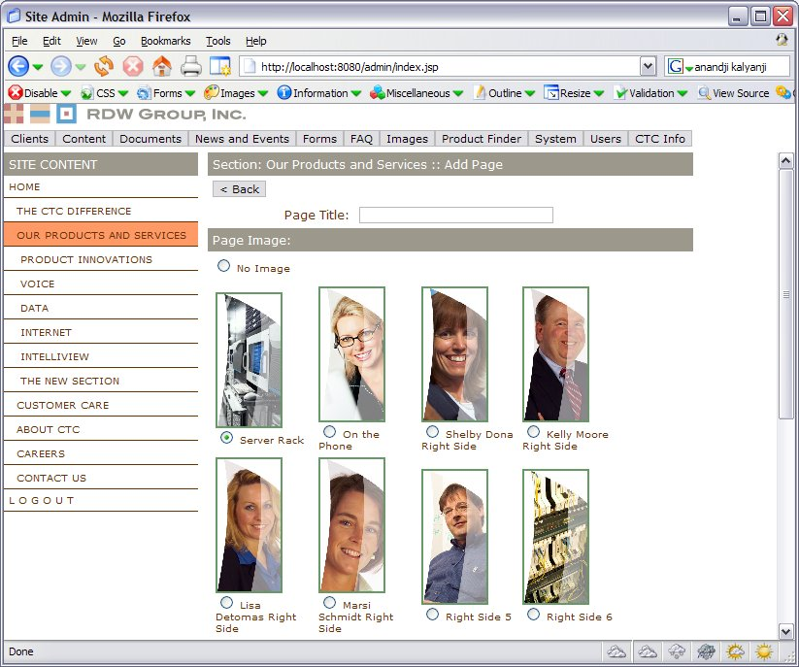

An Add Page screen asks the CIAO administrator to provide the page’s title and image. The new page will appear as the last page in the page order, and will initially be hidden from the navigation, allowing the administrator to enter content for publication on the site.

Hardware and Software Recommendations and Assumptions
IFactory is a technology agnostic firm. We believe our solutions should not dictate the development environment of our clients and, in fact, the technology preferences and directions of CIAO should dictate our approach to defining an appropriate development environment.
That said, IFactory is a best in breed provider of web and interactive services. We use and employ relevant, time tested web application development tools, spanning Cold Fusion, .NET, Java and open source solutions. We collaborate with our clients in defining technical environments, crafting decisions that make economic and strategic sense for you, our client.

When available, we seek to mitigate schedule, cost and technical risk by employing tested and trusted third party technology and tools. We seek to exploit these options and avoid building a solution from scratch.

In terms of hardware configuration, to reduce the risk of data loss or down time, we recommend hard drives support RAID level 5 to handle disks failing; i.e. redundant hot-swappable disks and a RAID controller to span the drives. In addition, the database should have at least daily hot backups and weekly cold backups.

The file system should be backed up to media stored offsite. Many ISPs will also provide a networked backup solution that could be attractive if they store the media offsite and can demonstrate their ability to retrieve files from the backup. We architecture our software in such a way that all processes are redundant and isolated from one another. All systems are designed to come back to a normal operating condition when the server is rebooted without user intervention.

We typically call for hardware specifications that will handle expected usage peaks. Hardware costs are relatively cheap in comparison to the overall development costs and therefore it does not make sense to skimp on the hardware side. We have quite a bit of flexibility with this site because the data will not be changing continuously, meaning if demand outpaces the ability of the servers we have a number of options for growth. We can add CPU’s to the servers, we can add memory and we may add disk space as necessary. Our proposed architecture is modular so we can spread the components out across multiple servers. And finally we can replicate the site on multiple live servers if CIAO required such expansion.

Again, our goal is to accommodate – as opposed to dictate – your technical direction and we welcome your direction and suggestions.
Given CIAO’s objectives in balancing functionality, an optimal hardware solution and budgetary objectives, IFactory will work with CIAO to define options for reducing server hardware costs by employing various avenues (such as the ability to piggy-back on existing Columbia University Press servers) during the first weeks of the engagement. Our goal will be to define a solution minimizing hardware cost outlays as required by CIAO. As such we anticipate the current CIAO project site will be able to enable the server configuration and cohabitate within the server set provided for Columbia University Press on our most recent engagement.

Recommended Design and Production Parameters
- Windows systems: We support Internet Explorer 6.0 and Netscape 6.2 and to Netscape 7.1 on the following operating systems Windows 98, 2000, ME, XP – SP2
- Macintosh systems: We support Safari 1.2, Internet Explorer 6.0 and up to IE 5.2 and Netscape 6.2 and up to Netscape 7.1 on the following operating systems MAC OS.9.1, MAC OS.X
- For Netscape 4.x and Internet Explorer 4.x and 5.x, unless otherwise requested, we will produce functioning text-based pages with simple in-line images and limited cosmetic design
- The final solution will be designed for baseline accessibility standards
- We will validate for XHTML Transitional unless otherwise requested in the kickoff meeting. We cannot be responsible for validating existing code or content which we are requested to keep intact
- We will design for a minimum screen resolution of 800x600 pixels unless otherwise requested in the kickoff meeting – this may or may not impact printability of the pages and should be addressed as part of the concept phase

Technical
- Linux environment with Java/J2EE and Perl scripting solution
- All data supplied by CIAO will either be in XML, PDF or a database format with previously agreed upon schemas
- Use, licensing, costs and permission of content or graphics usage are the responsibility of CIAO
- The site will be hosted in an environment compatible with the IFactory solution.
- Any required business rules or relationships will be provided by the CIAO in formula format in electronic spreadsheet
- We will identify potential enhancements or requested modifications to scope during the Architectural and Design Phase and will implement only those changes approved by the CIAO, thereby allowing you to control your project’s scope, budget and schedule
- As part of the concept phase a determination can be made to pursue additional usability testing as part of the development phase.

Testing for CIAO
We have a comprehensive testing philosophy and test at every stage of development. As the development phase proceeds we incorporate more platform and stress testing to ensure code works on all intended platforms and under real-world conditions. Platform and stress testing is typically focused during the beta period of development. The IFactory Producer will work with CIAO to define bug categories and the meaning of the different bug severity levels. CIAO will be given direct access to the bug database and will be able to track the progress of the bug fixing process at all times.

We will divide testing into the following categories:
- Unit Testing
- Integration Testing
- Functional Testing
- Load Testing (where necessary)
- Platform Testing
The first three types of testing are concerned with the functionality of the CIAO application; does it work and is it robust under unexpected inputs? Unit and integration testing are fundamental parts of our development process and help to ensure code continues to work as bugs are fixed and new features are added.
Unit Testing
Developers create unit tests as part of their development efforts. These test scripts allow our developers to verify the logical units of code they develop continues to work as expected over the course of the entire project cycle as bugs are corrected and interfaces adjusted.
Integration Testing
As units are brought together, integration testing is initiated to ensure the units perform together as expected. This testing ensures that integrated units of a project are working. The interface specifications are enhanced to include expected software behavior under both normal and unexpected user inputs.
Functional Testing
As we prepare to make the first interim release for a project a functional test plan is created. This plan is created by collecting all of the individual integration plans, and delineates in detail all of the interface components of the software and the expected results from interacting with each of the components. This plan is closely correlated to the actual software; consequently we confirm specifics such as the following:
- All input fields should be defined; the range of normal inputs should be specified and the behavior for input outside of the normal range is specified
- The behavior for all click-able components on the page should be specified
- The size and shape of dynamic elements should be indicated
- The relationship of different screens or pages is explained
- The plan should allow a user who is unfamiliar with the project to test the product
Load Testing
We will need to load test the delivery of the modules from the online site. The load testing under simulated traffic loads will be used to ensure that this has been accomplished.
Platform Testing
We will work with CIAO to define the set of platforms and operating systems the application will support. We will define the minimum characteristics for PC or Mac user accessing the site. We will create a stress testing matrix and test the application on minimum configurations to ensure that the software meets the requirements.

CIAO Administrator Training
Throughout the project, IFactory will work with the CIAO team to define site organization, content, functional components and administrative functionality. The navigational prototype reviews, content inventories, storyboards and specifications all act to confirm and communicate the site’s public facing and administrative components and contribute to a consistent engagement and collaborative educational experience for the CIAO team.
One goal of our iterative process is to avoid a black-box development cycle. Our reliance on CIAO’s iterative feedback and input enables us to easily communicate the “whys” and “hows” associated with the application solution and site configuration. As such, the site will be familiar to the CIAO web team upon delivery. That said, training on usage and administrative nuances is still required following delivery of the site.
To assist CIAO in optimizing the organization’s investment, IFactory plans to provide one half day training session working with CIAO in order to migrate administrative knowledge from the IFactory team to the CIAO team. Such side-by-side collaboration usually takes the forms of an on-site session, during which we work with the CIAO administrator(s) to update content, and ongoing phone support, during which we answer questions and discuss the system during the first month of usage. Such an approach complements our delivery of all source code, style sheets and templates to the CIAO team upon conclusion of the engagement.
In summary, our goal is to provide you with the system, the underlying code and the ability to operate the system. The result will be a full transition and the ability of CIAO to use external resources such as those provided by IFactory judiciously. Our goal is to teach you to fish, not to sell you fish.

Optional CIAO Electronic eNewsletter and Email Tool
Based on your requirements, we may wish to implement our E-Wordworks software framework in order to enable CIAO to proactively communicate with various user audiences of each of your sites. The application represents a comprehensive tool allowing CIAO to create multi-page Newsletters and provides you with the tools to manage your mailing list and send targeted HTML (or text) emails. By uploading your mailing lists to the system, CIAO will be able to send group emails or e-Newsletters to targeted segments of users for the site. Users receiving the e-Newsletters will be able remove themselves from the e-Newsletters mailing list by opting out at any time.

Features of the E-Wordworks approach include:
- Segmented user security to allow for multiple contributors
- Streamlined template import and export
- Easily add eNewsletter graphics and side bars
- Easily add email graphics
- Image upload
- Robust email campaign reporting

Newsletter Creation
Create Newsletters from Multiple Templates – the system will be designed for users to create the Newsletters, such as centered and with or without table of contents. Our intuitive interface allows your users to see the changes as they happen so that you can easily make adjustments.
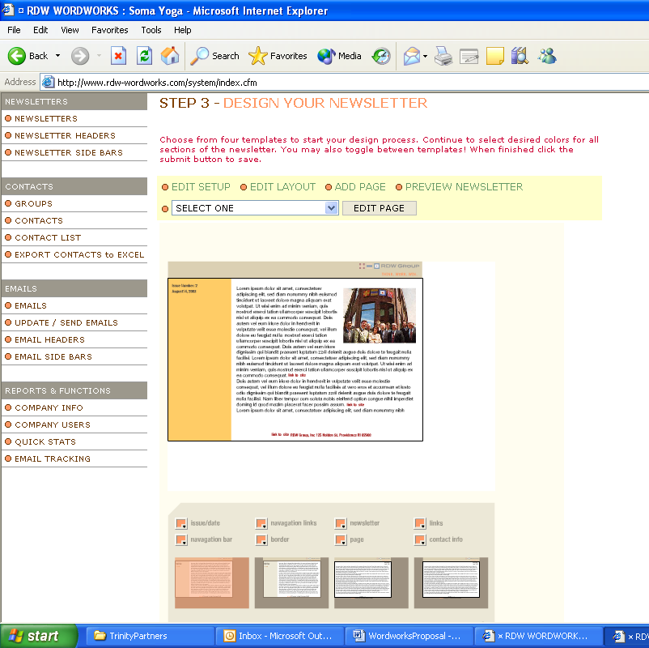
Screen 1 – Design Your Newsletters and See Changes Immediately
Create Different Audience Groups – The E-Wordworks system will allow you to segment your audience by creating any number of groups which could receive your emails or eNewsletter. This allows you to add contacts to these groups at a later time and add to the lists as you desire.
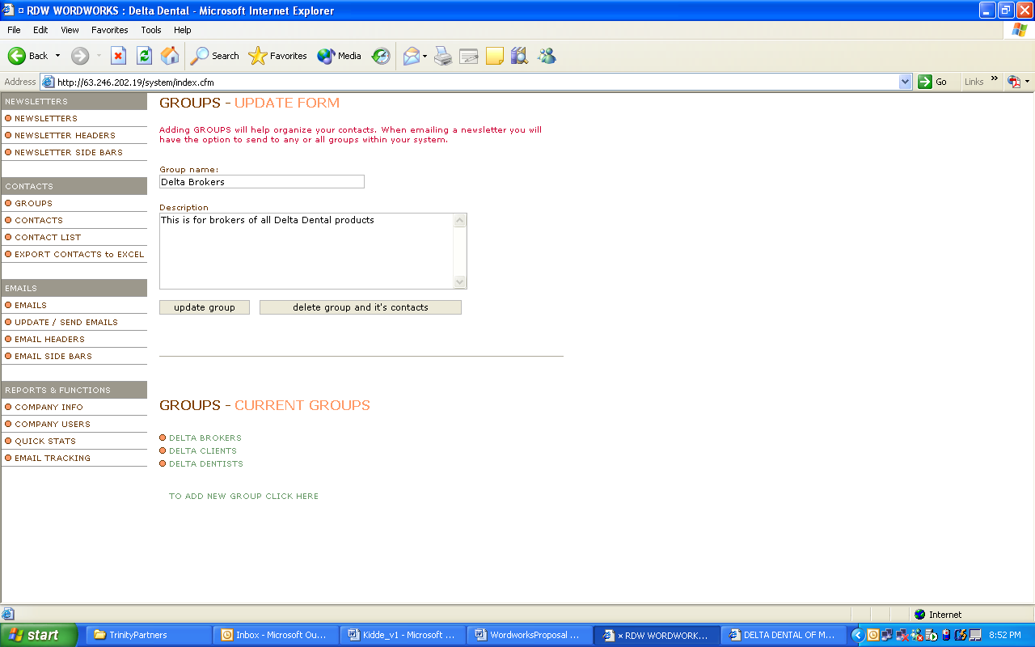
Screen 2 – Easily Create New Groups
Add/Import Contacts into Groups – Using an Excel template, you can easily import the names into the system and assign the lists to different groups to segment your audience.
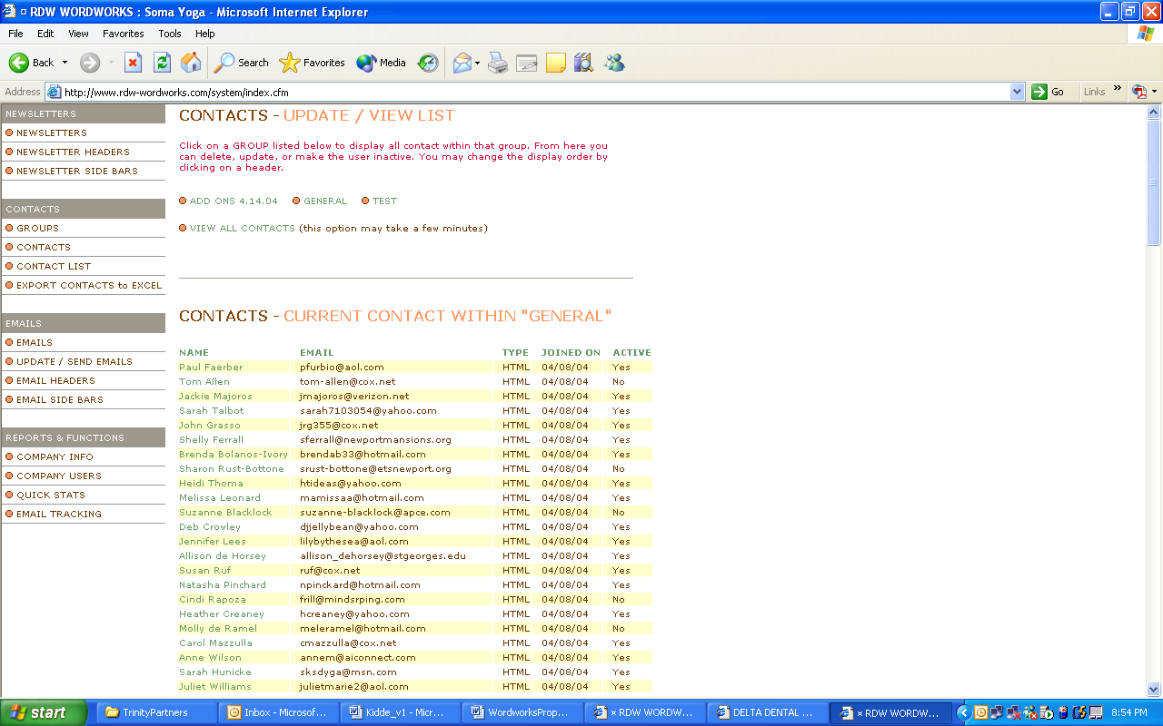
Screen 3 – Manage Your Contact Lists and Assign Them to Different Groups

Automatic Opt-Out - Users can opt-out by simply clicking a link on the email they receive. No additional work is required.
E-Mail Message Module
The E-mail creation tool provides a variety of ways to communicate with your audience members. CIAO may create an email message which will drive traffic to your site. You may also personalize your emails so that only certain audiences can read certain articles from the eNewsletter.
Create HTML e-mails to Drive Traffic to your Newsletters – Our approach allows you to create an email in one of three versions (Regular, Advanced, Standard) depending on your requirements.
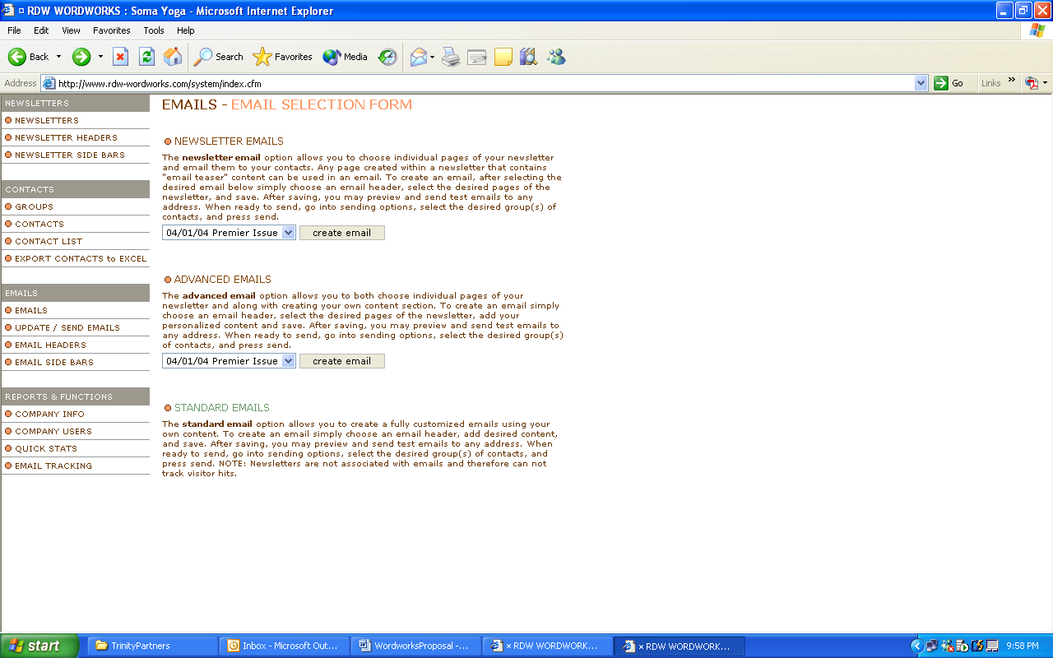
Screen 4 – You Can Send Emails in Three Ways
View Traffic/Response Reports – Our system allows you to keep statistics on how many emails were sent, how many were read, and which formats (HTML/Text) were read more predominately.
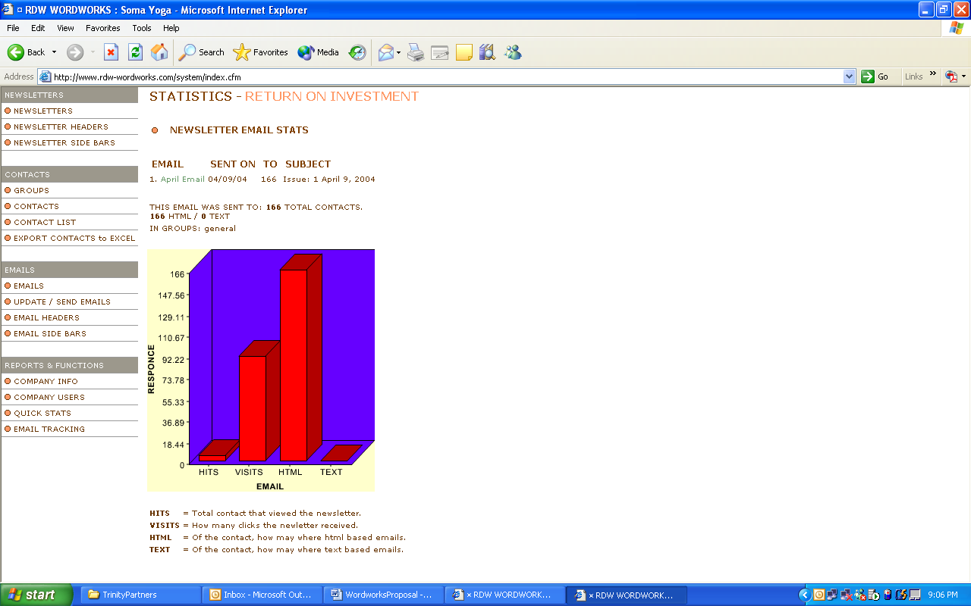
Screen 5 – View Reports to See Your Return on Investment

Optional CIAO Maintenance and Support
Following Gold Delivery, we would like to continue to support CIAO as the organization sees fit by potentially providing enhancements or adding features based on user feedback and preferences within the new CIAO web site.

Upon completion of the project, IFactory will work with CIAO to establish a constructive follow-on relationship complementing the needs and desires of CIAO. For web development engagements such as the endeavor CIAO is pursuing, we often recommend a retainer-based relationship, whereby CIAO procures support for a predetermined set of fixed monthly hours and we provide you with a discounted hourly rate for that service.

In such a case, IFactory works with CIAO to define an appropriate quantity of hours for allocation each month and we do not exceed this without pre-approval from CIAO.

Following the completion of the site, we will coordinate with CIAO in order to define a quantity of hours required to support the new application. Though we will confirm the hours at the conclusion of this project, we anticipate the maintenance of the site will not require more than 16 to 20 hours per month.

In addition to maintenance, IFactory offers a warranty for a period of up to 90 days providing for no charge repairs to bugs or errors in the IFactory code. Should you ask for new changes to the site or request additional elements or functionality (for example the addition of a form or a new navigational section) we will allocate maintenance hours or provide CIAO with a scope change for your review. You may then determine if and how you wish to proceed with the change. Should CIAO opt for the maintenance plan for the site, the change will then take place under a maintenance agreement. It is usually the case that the warranty period and maintenance agreement run concurrently during the first 90 days as such a period experiences both bugs (covered under the warranty) and suggested enhancements (covered with a change in scope or maintenance arrangement).

Proactive Application Management and Support:
Monthly maintenance is framed within a proactive as opposed to reactive mindset. Monthly support includes the investigation and analysis of all problem reports which have been forwarded to IFactory and the correction of all defects and errors in the site so as to ensure that the site is free from all material defects and operates as expected, and the supply of such corrections to CIAO (including updated source code). Such services include the following proactive support:
- The correction of all defects and errors in any documentation so as to ensure that the documentation accurately and completely relates to the site in its current state;
- Site Monitoring
- Project management including providing agreed upon status memos, testing, scheduling, tracking

All fixes, corrections and updates will first be carried out by Interactive Factory in the development environment, will then be promoted to the test environment for testing and will only be sent to the production environment when approved by CIAO.

Post launch tactical site enhancement support encompasses front end or application support as follows:

Content and HTML Modifications: Covering the following services:
- Content Maintenance: provide content updates throughout the application
- Graphics Maintenance: install new graphical elements in the existing site framework
- Scripting Maintenance: modify or enhance existing scripting requirements

Database and Application Support: Covering the following services:
- Database support: providing modifications to the schema and database to reflect additional data storage, collection and reporting needs
- Functional modifications: architect and develop new functional components for and integrate with the existing site
- Integration: specify and integrate with additional third party applications and data sources

Monthly Support: For planning purposes, the IFactory Bug Database may be used for reporting and tracking task requests that are to be performed as part of the retainer agreement. IFactory requests that CIAO use the Bug Database to make requests and IFactory will respond to requests either with further questions or an estimate of what will be involved to complete the task. IFactory will make every attempt to schedule tasks for completion within three business days of confirmation of scope and time estimate to complete unless otherwise agreed to between the IFactory and CIAO. Tasks that require an excess of agreed upon hours per month will be scheduled as soon as possible or may be deferred to the following month following discussion with CIAO.

Emergency Response Time for Bugs: Emergency maintenance tasks will be addressed within one (1) business day of formal notification to IFactory (e-mail notifications will suffice). Hours may be used for emergency maintenance tasks. If the designated quantity of hours has been exceeded for the month, Emergency maintenance tasks hours will be billed on a T&M basis. IFactory agrees to resolve emergency maintenance tasks on the following basis:

- Level 1 Emergency: The most severe bugs which render a portion of the system unusable and there is no existing workaround. IFactory will either fix the bug or back the system out to the previous working state upon notification of the bug and will address the situation in no more than 24 hours of notification from CIAO.
- Level 2 Emergency: Severe bug which makes it difficult to use the system in the manner intended but does not totally cripple the system. IFactory will either fix the bug or back the system out to the most recent working version within 48 hours of notification from CIAO.
- Level 3 Emergency: Less severe bug which the user can get around in one way or another. IFactory will resolve these bugs within seven (7) working days of notification from CIAO.

Hourly Rate: Any hours incurred will be billed on a Time and Materials (T&M) basis at the end of each month, at the rate of $150.00 per hour.

Monthly Status Report: Interactive Factory will provide a monthly status memo to CIAO outlining the hours used to date and any anticipated tasks for the month to come. Incurred hours will be reconciled every three months. Any unused Retainer Fee hours at the end of each three month period are not carried forward and, as a result, we recommend allocating to preplanned micro-projects or larger CIAO requests.

Web Site Application Development Assumptions and General Parameters
With an eye on the aforementioned application development design, the below information is provided as a best initial estimate of web service scope of the engagement. Site production includes the following assumptions:

- The web site interface will include the following:
  - Single home page and single master template
  - Single navigational solution
  - Up to 12 unique presentation screens, each requiring one unique design layout
- Hosting; scripting environment will be defined by IFactory and CIAO with the goal of using the existing Columbia resources in an effort to save funding
- Web service users and administrators will access the web service from corporate high-speed environments and will employ Netscape 6.2 and/or Explorer 6.0 web browsers.
- During the initial phase, IFactory will work with CIAO to define the required level of accessibility compliance. IFactory will proceed after confirming recommendations and decisions with CIAO.
- Save for the link to the subscription management system, integration of third party applications or solutions are available with a change in scope
- IFactory will enter up to 10 records in each database element for testing purposes and CIAO will enter the remaining content following IFactory training
- The recommended solution will be confirmed during the architectural phase and use of other applications may require a scope change
- Licensing, content, ecommerce services and credit card processing, third party software, email, and other third party fees are not included in this proposal unless otherwise provided as line items
- Hosting, hardware and the eNewsletter are priced as and provided as optional services
- The current engagement does not include frames, animation, Flash, DHTML or custom graphics design save for the application’s actual visual identity and design
- Content will be provided by CIAO in a single electronic delivery to IFactory in a manner compatible with content specification guidelines provided by IFactory. IFactory will allow for minor content amendments and updates, however, large changes in content format and the frequency of deliveries will require a change in scope
- Use, licensing, costs data security, and permission of content or graphics usage are the responsibility of CIAO Web service will be hosted in an environment compatible with the IFactory solution
- Changes to design, content architecture, or data collection or delivery after the architectural phase will require a change in scope (which may impact schedule or budget)
- Any required business rules or relationships will be provided by CIAO in formula format in electronic spreadsheet
- All costs and expense such as travel or meals for user studies are not included and will be passed through to CIAO. CIAO is responsible for identifying, recruiting and producing users for interviews. Travel or user expenses (such as comps) will be invoiced to CIAO as expenses.
- Travel expenses such as airfare will require approval from CIAO and approved costs will be expensed to CIAO
- We ask the CIAO to provide a single point of contact in order to facilitate decision-making
- We will identify potential enhancements or requested modifications to scope during the Architectural and Design Phase and will implement only those changes approved by the CIAO, thereby allowing you to control your project’s scope, budget and schedule
- CIAO will own all final deliverables and all code upon project completion and final payment.

Task Chronology and Budget
Phase I: CIAO Architecture and Design
Confirm Concept and Define Architecture Stage:  - Kick-off Meeting defining roles and process  - Define audience objectives and web service objectives via project profile (two rounds)  - Review up to three months of traffic reports (one round)  - Review up to four competitor sites (one round)  - Content inventory (two rounds)  - Site map (up to three round)  - Use case scenarios for up to six user transactions (two rounds)  - Work flow maps consisting of up to three administrative transactions (one round)  - External storyboards consisting of up to 12 screens (one round)  - Administrative storyboards consisting of up to six screens (one round)  - Navigational prototype with up to 12 external and six administrative (one round) noting any changes  - Review of navigational prototype (one session)  - Review and confirm technical environment (one round)  - Functional Specification (two rounds)  - Confirmation or modification to Phase Two requirements  - Concept Brief Presentation  - Concept Brief sign off | 125 hours
Design Home Page and Primary Interface Templates:  - Art direction for themes and online branding (one round)  - Photo research (one round)  - Design three home page and master template mockups (one round)  - Following CIAO’s selection of the mockup candidate, provide two rounds of iterations on the selected mockup (two rounds)  - Design up to 12 derivative sub section templates(one round)  - 12 derivative sub section screen revisions (one round)  - Review and sign-off | 120 hours
Project Management – including Work Flow, Communications, Resource Management for approximately six weeks for Phase I | 40 hours
Total Phase I Estimated Hours | 285 hours
Total Phase I Estimated Cost at $175 per hour | $49,875
Discounted Total Phase I Estimated Cost at $150 per hour | $42,750

Phase II: Site Production and Development Implementation Estimate
Deployment Stage:  - Confirm hosting and technical environment (one iteration)  - Gather and review content for final site (one round)  - Define administrator log-on and authorization mechanism for three levels of administration (one round)  - Define and implement administration field naming conventions for pages supported by content administrator  - Page specs for up to six dynamic content types (one round)  - Final table structure for administrative solution housing up to six primary display types (one round)  - Author Technical Specification (one iteration)  - Technical Specification sign off  - Production and integration of home page and master template  - Production of up to 12 unique screen templates  - Development and configuration of the following modules as noted in the executive summary:  - Subscription Management System and access control module for the web site  - Main CIAO site including the Home page, marketing pages, search, browse and all content related pages for all of the CIAO content  - Publication Management System  - Reporting  - Install SSL  - Install product catalog  - Search engine installation and configuration  - Asset Production  - Site testing and quality assurance  - Documentation for admin team and functionality  - Training of primary administrator(s) in one half day session  - Deployment of the new working site | 625-700 hours
Project Management – including Work Flow, Communications, Resource Management for approximately ten weeks | 70 – 90 hours
Total Phase II Estimated Hours | 695 – 790 hours
Total Phase II Estimated Cost at $175 per hour | $121,625 - $138,250
Discounted Total Phase II Estimated Cost at $150 per hour | $104,250 - $118,500
Optional WordWorks Newsletter Tool | $5,000 per year

This proposal has been formulated based upon our understanding of your CIAO project. Schedules and costs are subject to change. This proposal is valid for 30 days and we welcome your comments. Please ask us to answer questions, revise the document, or discuss your preferences, as our goal is to understand – and then work to exceed – your exceptions and goals. Please feel free to contact Glenn Morgan at 617-426-0609, x 876, with your questions or comments.

Appendix A: About IFactory
Interactive Factory was founded in 1992 to engage, communicate, and inspire through the promise of multimedia. We thrive on the fundamental media challenges of information architecture, content, usability, beauty, and innovation. We believe in the fusion of purpose and play: that functional, useful tools should also compel.
This clarity of intent drives our process, which we have honed through years of hands-on experience. We focus on ensuring our solutions meet the particular needs of both our clients and their end-users. A firm grasp of technology, design, and project management enables us to consistently maximize client satisfaction.
Our people and our process work to demystify the often difficult language of art and design. We articulate every decision, involving the client at each step to ensure a "no-surprises" evolution of interface, functionality, and art direction. Our engineering knowledge spans a comprehensive understanding of legacy database systems to the latest content management tools. Our project management skills are directed at producing the best possible solution within the given timeframe; balancing media dreams with business realities. Our culture of critical evaluation, self-examination, and testing ensures the highest quality for all our products.
The pedigree of our clients is second to none.
Most of the IF team have been with the company for years, and nearly all of us have been a part of the industry since its inception. We are Interactive Factory: a committed team of individuals working every day with a mission to deliver the application of new media to complex data management problems.

Appendix B: IFactory’s Long-term Value Proposition
IF seeks to serve both your immediate needs and your long term objectives. We provide a unique application of visualization to complex data and content management challenges. When determining whether IFactory will help CIAO meet your evolving requirements you will ask if we will best meet your requirements. Our answer is yes and our reasons are noted below.
- Because we have proven success in developing sophisticated large-scale projects for the likes of Oxford University Press, Greenwood Publishing, RR Donnelley, Reuters Media, Pearson Education, O’Reilly Press, LEGO, Sky Publishing, Boston Museum of Science, Harvard University, MIT’s Sloan School of Management, The Harvard Center for Cancer Prevention, Yale Law School, Tufts University, WGBH Interactive, Wheelock College and World Bank and many others.
- Because we are prepared to support the full scope of CIAO’s long-term Internet and New Media initiatives. We have the ability to scale to your needs whether for regular maintenance, site enhancements, or the development of an entirely new website.
- Because our balanced staff of designers, engineers, and project managers will provide CIAO an easy to manage "one stop shop": Our designers and engineers have extensive experience building fully custom object-oriented databases, on-line media repositories, decision support systems, and database-driven electronic publishing systems.
- Because in a time of economic flux for many of our industry peers and competitors, we are proud Interactive Factory remains a privately held, profitable, and stable business.
- Because we are committed to building relationships and partnerships that last, and to that end, 90% of our new clients become repeat clients. Our customers continue to work with us because we have proven time and time again we deliver successful solutions on time, and on budget.
- Because we have the experience and resources necessary to train your staff on both the day-to-day and long term management of your website's growth.
- Because we are confident in our ability to manage every aspect of any this development initiative.

Appendix C: Approach to Defining CIAO’s Content Management Solution
The following section outlines our approach to constructing a content management solution on behalf of CIAO. In general this section provides an overview of how we think of defining content administration and workflow solutions. The section does not include a description of a pre-packaged or previously coded solution. We believe CIAO’s content management solution should not have to conform to an existing set of constraints. CIAO’s business objectives should drive the development of the solution that best serves your marketing needs. This section seeks to provide an overview of how we approach the specification of such a system.
Definitions, Motivation
A Content Management System (CMS) consists of any software or process used to alter or maintain the contents of a website. In CIAO’s case, we are focused on a solution providing easy-to-use tools for managing web pages. The CIAO solution is relatively straightforward and will focus on managing information, titles, author information, related content or articles, documents, events, programs and imagery, whose primary goal is to communicate to multiple audiences seeking specific title or author information from CIAO.
Website Architecture
Every website is built using a wealth of software and hardware technologies. Typically, operating systems provide various network services that may be used for updating content on the website, including FTP and native file services such as NFS, Samba (Windows networking) or AppleTalk. The most primitive and probably most common content management system looks, to a user, like an FTP connection and an HTML editor; be it Dreamweaver or Notepad. More complex data-driven websites typically rely on relational databases (such as Oracle or SQL Server on the high end and MySQL or MS Access on the low end) and scripting languages such as Perl, Java, Python, PHP, TCL, or even Visual Basic. These technologies are the raw materials with which content management systems are constructed.
Many tools touted as content management systems are in fact what we would consider merely development platforms. These tools or systems provide capabilities that go beyond the basic infrastructure outlined above, but lack many of the features that characterize a content management system as we understand it, such as workflow and collaboration features and forms-based content editing.
Web development platforms typically provide some mechanism for meshing executable script code (Perl, Java, etc), HTML templates, and content (text and graphics). Many different approaches to this basic problem have been taken and no one of them is best in all situations. However, a vague consensus has emerged around the idea of commingling HTML and little snippets of script code in the "template" files, while removing larger more complex pieces of script code into separate "library" files. The web development platform handles the details of making this all hang together properly: processing the script code, compiling, caching and invoking it, and interpolating its output with the various HTML template fragments around it.
Exactly what is the best way to do this depends on the people that will be maintaining the site: what their skills are, how often they are available and how well they work together. An often-cited "typical" organization is to have one person responsible for HTML templates and another for scripts. However, CIAO’s site will require decentralized administration as well as centralized approval.
Four Levels of Content Management
Our basic philosophy regarding defining a CMS best serving CIAO is "less is more." Basically you and the administrators are best served by as little technology as you can get away with. Why? This is partly a matter of cost, but it's also a question of convenience: sometimes too much technology can get in the way of the people it is supposed to be helping, some of whom at the page or section level may not be comfortable with web administration. First consider the costs: content management software package prices range from zero to hundreds of thousands of dollars. More expensive packages typically come with consulting costs for setup and ongoing maintenance. These consulting arrangements are required because of the complexity of the software systems and it is difficult to account for the so-called "hidden costs" of training and support within the organization that is supposed to be getting the benefit of the new software. Of course this is not to say that these packages are not useful and necessary, just that misused, they may cause more harm than good.
As such, it is important to ask what problem you are trying to solve with a content management system before committing to spend the time, effort, and money required to acquire and deploy one on behalf of the marketing, editorial, product and technical teams. How can you tell if you need a content management system, or rather, what kind you need? The basic metrics are: amount of content to be managed, the frequency of updates, and the number of people responsible in some way for managing, updating, or maintaining the content. In terms of our approach, we will work with CIAO to define the needs and then work within a set of four general categories of CMS solutions in defining a system best serving CIAO.
Level 0 Content Management
Our first level, level 0, of content management, could be considered no content management at all. This level is typified by a small website (less than fifty unique pages) managed by a single individual. Often these sites are maintained "by hand" using file copy operations, perhaps FTP if the server is remote. Typically HTML is edited using a tool such as Dreamweaver or Front Page, or possibly a simple text editor, in conjunction with image editing software such as Adobe PhotoShop for graphics. Best content management practices in this scenario involve maintaining dated backup copies of the website files in a secure area. This setup is primitive, but for the number of pages and people involved, it is probably the best. Version tracking, workflow, scheduled publishing, and other high-end content management features are unnecessary, and working around them would only make editing such a site more inflexible and inconvenient.
Level 1 Content Management
The first automation often added to a site is simplified publishing tools, usually web forms, for editing content. Often the motivation for adding these tools is website administrators are fed up performing repetitive site-maintenance tasks; typically posting content for others with less web knowledge. A typical scenario is a set of forms for posting jobs, press releases, calendar items, and other specialized content. These forms can be used by people without HTML training and tools. Again, these tools provide benefits, but they come with "hidden costs" as well. When content is managed using such tools, control over the visual presentation and link structure of the website is sacrificed to some extent. Convenience and ease of use come at the expense of power and fine-grained control. Determining whether these tools are appropriate will depend on the exact kind of content, the frequency of updates, and the personnel involved: How repetitive is the format? How often are changes made? Is the content originator also maintaining the web pages?
Tools particularly targeted at this niche are limited primarily because the benefit is small and the needs vary widely from site to site. Often custom web page management forms are purchased in the context of a website redesign or overhaul. Also, some hosted content management solutions are available that provide forms-based editing at a low, albeit recurring, cost, while including rudimentary implementations of other features that may be ignored or bypassed.
Level 2 Content Management
An increase in any of the basic drivers of the complexity of maintaining a site (number of pages, number of people, and frequency of updates) will necessitate the addition of supporting tools. The tools required will vary depending on the problem. For that reason, the "middle tier" content management solutions are highly varied in the kinds of capabilities that they offer. Often systems of this sort are constructed from a hodge-podge of standard software components and some custom programming to glue them together. The reason for this is that almost no site truly requires all of the features listed in this category. Many people are looking to content management to solve just one or a few of the problems that these tools address. Currently, most software vendors have targeted their solutions to the high end of the market.
Level 3 Content Management
When the number of people, and the amount of content, and the frequency of updates all increase, and generally speaking the complexity of the websites increase, organizations will find more complex tools are required. Currently, there are many vendors providing soup-to-nuts content management platforms that include almost all of the features described thus far. We refer to these as "level 3" content management systems.
The one feature distinguishing most of the higher-end systems is the introduction of a conceptual layer between the content and the website. This is a necessary consequence of building systems that try to be all things to all people. They can handle all types of content, from all sources, and attempt to solve all content management problems. In order to do this, they introduce conceptual machinery that can be difficult to understand and may actually present a barrier to implementation in some cases. It also means simply purchasing the software is never enough. To make these systems useful to a content editor, it is always necessary for a technologist with special training to set up the system and tailor it to the particular needs of the organization that bought it. Often, this technical support must be carried out into the foreseeable future.
For some organizations this is an appropriate allocation of resources. Any company or group whose primary focus is delivering content on the web should consider these systems carefully. But for many, the web is only a vehicle for promoting and communicating the message of an organization, most of whose business is conducted elsewhere. These organizations typically do not have websites that are complex enough, or involve enough people in their management, to make a full featured content management system a necessity.
Picking a Solution
In summary, it is a good idea to assess the needs of your organization and to try to pick a web management solution that matches those needs. We do not recommend staring with a solution and then conforming your content management needs to that pre-existing solution. We believe the appropriate solution is generally one that provides the minimal amount of technology that will still encompass all of the particular issues in managing the CIAO site. Our hope is that the framework presented here will assist in sorting out the myriad issues involved in picking a content management solution.
The initial portion of our engagement will focus on confirming goals, organizing content, defining functional requirements and designing the visual aspects of the site. Following this portion of the project, we will be positioned to confirm implementation and technical requirements including the potential content management system.

During the Specification Phase we will work with the CIAO team to document the organization’s content administration needs. Specifically, we will review the CIAO content administration process in order to determine if the process supports CIAO’s immediate and long-term site objectives. We will be looking to understand who will be responsible for managing content, their technical ability as well as the number of content editors and if an automated workflow is needed. As the answers to these questions will direct us in a number of content management solutions we envision creating tools that manage specific sections of the site, where CIAO anticipates a frequent schedule to update content.

For estimation purposes, the functionality we envision will consist of:

- Content Administration Tools to manage up to six primary content types (note, as noted in the design section, the quantity of sections may be defined to be more or less than six during the initial architectural phase) of the site in a pre-defined templated approach
- Multiple content editors who will need access to the administration portion of the content administration tools
- Minimal workflow and approval for the content updating process with, perhaps, two levels of approval
- All content administration tools will be based on a single navigational template

During the specification phase, we will confirm the content administration solution requirements with CIAO and work with you to define options and determine an appropriate course of action in collaboration with CIAO’s marketing and technical staff. The result will be a solution matching your specific needs.

Appendix D: Sample Projects

Oxford University Press
Oxford Dictionary of National Biography
www.oxforddnb.com

The Project

The Oxford Dictionary of National Biography is a collection of 50,000 biographies of individuals who have shaped all aspects of Great Britain’s past, from the beginning of recorded time to the end of 2000. The stories of lives presented in print and online, was the publication goal of the Oxford University Press. Replacing and extending the original Victorian Dictionary of National Biography, the Oxford Dictionary of National Biography is known to be the largest co-operative research project ever undertaken in the humanities. Over a 12-year period, a team of academic editors and publishers coordinated the work of many thousands of writers worldwide to re-create one of the great English reference works for the twenty-first century.

For the publisher, the Web site represented an opportunity to present both the brand of the dictionary and of the company, and to consolidate Oxford University Press’s presence in the online reference market.

Data organization would be a challenge: The dictionary contained 55,000 new articles, 10,000 original Dictionary of National Biography articles, 10,000 images and 10,000 contributors.

The organization of the site would be critical to its usefulness for the users. Subjects would need to be searched on a variety of categories – birth, baptism and death dates, places and dates of residence, places of education, historic impact, political office, and more. Adding to the complexity, the entire full text of the Oxford Dictionary of National Biography – all 95 million words -- would need to be searchable and the text of the articles needed to be tagged to make searching for references of particular people or places or works of art possible.

The users of the site would be broad, from the specialized to the general. Principal users would be humanities scholars, general readers of biography, students, family historians and genealogists, local historians, professional writers, librarians, archivists and curators. The primary market would be libraries, principally academic libraries, although public, museum and corporate libraries also subscribe.

Because of a coordinated global marketing campaign, the public launch date of the site was fixed. There would be a very public launch with broad media coverage in every English-speaking nation.

Oxford University Press engaged IFactory to build the online version of the Oxford Dictionary of National Biography and deliver it on time.

Site Objectives

- Build a user-friendly, searchable Web site.
- Increase online subscription sales.
- Maintain the Oxford University Press’ reputation for excellence in the representation of the online version.

Planning and Strategy

In order to meet the unmovable launch date, a highly detailed project schedule was created and implemented. IFactory started the project with a four-month period of reviewing the necessary technological needs of the site and an in-depth art direction and site architecture concept phase. From this planning phase, we developed a complete development schedule. Because of this exercise, we were able to move forward quickly because all of the end-use questions had been answered. We worked constantly with the client, based overseas, to keep track of outstanding issues and to keep reprioritizing them as the development process proceeded. To guarantee that no question went unanswered for more than a few days, we instituted a weekly client status meeting with all the decision makers. A very clear set of development guidelines were communicated to ensure that all parties would know the consequences of all decisions.

In addition to the Web site creation, Oxford University Press required tools to allow them to publish updates and add new biographies on an ongoing basis. Leveraging Oxford’s internal content management tools that manage the editorial process, IFactory deployed a publication management system that will allow Oxford University Press’s non-technical staff to manage the publication process between the content management system and the live site.

Cutting-edge technologies were employed to deliver the dictionary’s content in a flexible, searchable and user-accessible manner. The new technologies used were XML, XSLT, validated XHTML and the deployment of an advanced search engine technology with custom integration. The site is fast, reliable and accurate. The richness of the search interface and the addition of the theme concept have produced an initial “wow” reaction to the site.

All deadlines were met and the project launched successfully on the chosen day at www.oxforddnb.com.

Results Documentation

The Web site received 876,000 hits on the first day of the launch, and the hits have continued to climb since that date. On March 8, the cumulative number of hits was 19.3 million. Currently, 1,996 institutional and individual subscribers are registered on the site. The institutional subscribers, such as libraries, provide access to a great number of individual users.

Press Reviews The live launch met with great fanfare, especially in Great Britain and among the academic press. More reviews are documented in the supporting documentation portion of this entry.

“The greatest innovation in the Oxford Dictionary of National Biography is its online edition. With the ODNB, sophisticated internet-based publishing has definitely entered the mainstream. This is a resource you can use and enjoy, not just experiment with.”
The New Criterion, January 2005 (New York, USA)

“But the literary event of the year is the online debut of the Oxford Dictionary of National Biography (www.oxforddnb.com). A world of information, authoritatively culled and checked, written with wit, deftly illustrated, is at one’s fingertips. The huge website is superbly designed and easy to navigate. Who could ask for anything more?” Sunday Times, November 28, 2004 (London, England)

“How good is it? A perfect ten. With the themes feature in addition to the browsing capability, online has upped the serendipity quotient over print. This online file provides much more than the 60 printed volumes.”
The Library Journal, October 15, 2004. (New York, USA)

Peer Acclaim The site has won the Booklist's Editor's Choice for Best Reference of 2004. Additionally, the Oxford Dictionary of National Biography was named "Top of the List" by Booklist. The award in this category carries the designation of the "Best of the Best."
The site is a finalist for the Software and Information Industry Association’s prestigious Codie Award in the Best Online Reference Service category. The Codie Awards hold the distinction of being the only peer-recognition awards program of its kind in the industry, providing a unique opportunity for companies to earn the praise of their competitors.

Client Satisfaction The client has expressed their satisfaction by reengaging IFactory to work on various user interface features that will continue to produce “wow” reactions in the future.

Innovativeness of the Site

IFactory created a highly customized search interface tailored to the rich amount of detail available in the content. A highly specialized data scheme was devised to encode the bibliographic-dated details of the subjects’ lives. The challenge of presenting an online edition of a dictionary with so many search entry possibilities was similar to building a museum with a million doors. IFactory first researched the various needs and worked closely with the Oxford Dictionary of National Biography staff to create a user-friendly, approachable and valuable research tool.

Reviews
- “An astonishing piece of work: a colossal, beautiful, fully functional and utterly user-friendly engine of enlightenment.” Noel Malcolm, Sunday Telegraph, October 24, 2004
- “A world of information, authoritatively culled and checked, written with wit, deftly illustrated, is at one's fingertips. The huge website is superbly designed and easy to navigate. Who could ask for anything more?” Humphrey Carpenter, Sunday Times, November 28, 2004
- “How good is it? A perfect ten . . . Resoundingly recommended for all libraries.” Cheryl LaGuardia, Library Journal, October 15, 2004
- “. . . undoubtedly the history-publishing event of 2004 . . . a remarkable and sophisticated updating of a Victorian masterwork . . . an intellectual wonderland for all scholars and enthusiasts.” Tristram Hunt, The Times, December 11, 2004
- “An astonishing piece of work: a colossal, beautiful, fully functional and utterly user-friendly engine of enlightenment.” Noel Malcolm, Sunday Telegraph October 2004
- “It is difficult to overemphasize the value of the material on offer in ODNB. With full reference data appended to this extraordinarily rich textual content, the ODNB is a source for research, scholarship and reference which far exceeds its apparent coverage. Taken together with the online Oxford English Dictionary, this reaffirms the reputation of Oxford University Press (as if it needed any reaffirmation) at the apex of heroic, and triumphant, scholarly publishing ventures.” Stuart James (University Librarian, University of Paisley), Geography, Biography, and History, Volume 19, Number 1, 2005
- “This is a work that makes superlatives superfluous.” Geoffrey Wheatcroft, International Herald Tribune, September 29, 2004
- “. . . one of the greatest feats of scholarly publishing ever.” Jonathan Sumption, The Spectator, November 20, 2004
- “Related in good, spare, modern English, never pompous, tedious or dry, every story fascinates . . . The new ODNB will enrich your life, and the national life.” Matthew Parris, The Spectator, November 27, 2004
- “[the Oxford DNB] will surely be one of the great publishing achievements of this century . . . the writing is always clear, frequently graceful, and more than occasionally sharp. Of the tens of thousands of entries, hundreds are masterpieces of pen portraiture.” Benjamin Schwartz, Atlantic Monthly, December 2004
- “A momentous achievement” Sunday Express, September 26, 2004
- “The new Dictionary of National Biography is a national treasure, indeed an international treasure.” Richard Lofthouse, Financial Times Magazine, September 25, 2004
- “It's nothing less than the family snapshot album of the island race . . . one of the biggest publishing ventures ever undertaken in this country . . . The DNB is not just a prodigious piece of scholarship; it's also a mirror of Britishness.” Godfrey Smith, Sunday Times, August 1, 2004
- “One of the most audacious publishing programmes of all time.” David Smith, The Observer, January 4, 2004

 | RR Donnelley  Custom Publishing Application  www.rrdonnelley.com/pubselect
RDW Group-Interactive Factory worked with RR Donnelley to develop PubSelect(SM), the next generation custom publishing application.
PubSelect is a turnkey solution that enables publishers to quickly and easily enter the custom publishing market, without a costly technology investment. Targeted at the education and professional publishing markets, PubSelect builds on RR Donnelley's extensive experience in serving book publishers in the custom publishing market.
Using PubSelect, publishers can present a unique, branded website that allows professors to search, browse and select content from different sources and recombine it into a custom textbook that is then printed by RR Donnelley. Professors can also add their own content to the custom book, which is another capability that adds value to the final published product.
Kevin Cleary, Senior Vice President, Planning and Business Development, RR Donnelley Book Group, said, "The development of PubSelect answers one of our publishers' growing needs: the ability to provide their customers with dynamic access to their content, build a custom book and output a high-quality printed product. This new solution will enhance their potential to develop a profitable custom publications business."
A full product demo is available at: http://www.rrdonnelley.com/wwwRRD/Tools/DynamicPublishing/PubSelect/Demo/START_HERE.htm
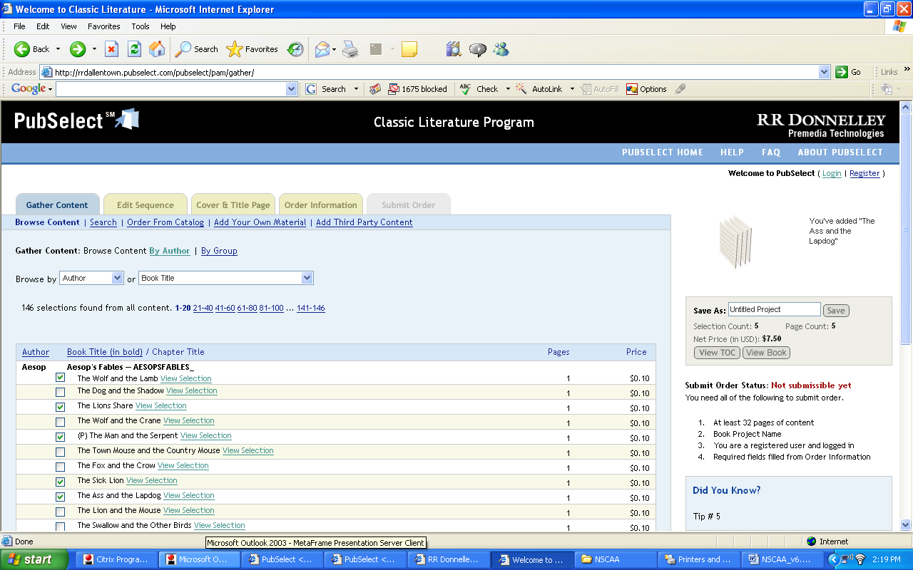

 | Sky Publishing  Sky & Telescope Website  www.skytelescope.com (go to Sky Chart)

RDW Group-Interactive Factory redesigned the Sky & Telescope Magazine site to complement their 60 year old consumer print publication. We performed a total site design, drastically improving usability and appeal. We created key interactive features such as the Sky Chart to attract new users. We added a Magazine archive to provide new revenue streams and provide a resource to long time readers of the magazine. We created a full-featured Editorial Content Management System for Sky's editorial staff to maintain the site.

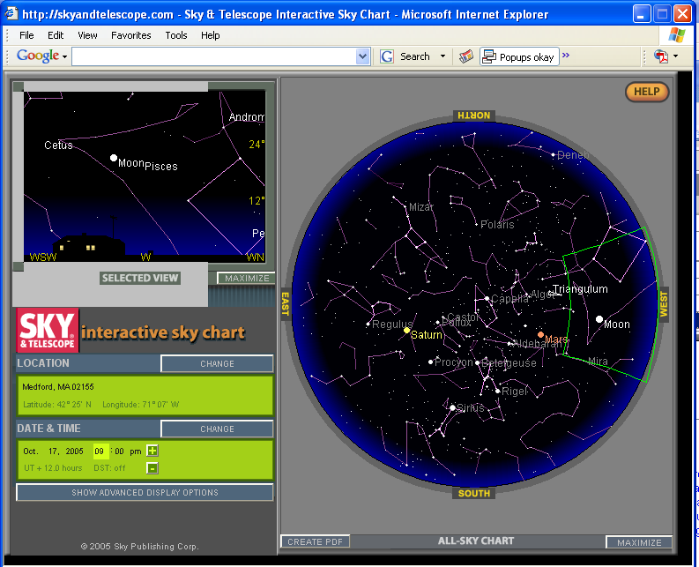

 | U-Lifeline Higher Education Portal  Technology: Portal Technology
Interactive Factory worked with the Jed Foundation in the development of an online mental healthcare library and portal serving 4,000,000 college students at over 400 North American campuses. The service provides a wealth of information and support to students at risk of suicide, and their friends. Our work began in 2003 by conducting an extensive user research consisting of surveys, focus groups and interviews. Interactive Factory conducted focus groups with both the student audience and on-campus counselors to determine the appropriate content to be delivered on the site and administered through the back end. Features of this portal include content management with several contributors from across the country, polls and surveys, document management, and an online community for students.

